1. Analyze the following circuit and determine the addresses of PORTA, PORTB and PORT C

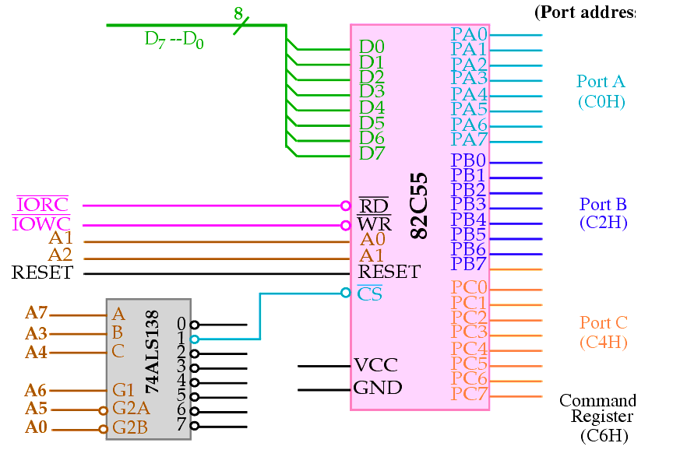

To activate the 3-8 decoder the address bits are-

A6(G1)=1

A5(G2A)=0

A0(G2B)=0

The truth table for the 3-8 decoder is given below-

|  |  |  |  |
| --- | --- | --- | --- |
| A4(C) | A3(B) | A7(A) | OUTPUT |
| 0 | 0 | 0 | 0 |
| 0 | 0 | 1 | 1 |
| 0 | 1 | 0 | 2 |
| 0 | 1 | 1 | 3 |
| 1 | 0 | 0 | 4 |
| 1 | 0 | 1 | 5 |
| 1 | 1 | 0 | 6 |
| 1 | 1 | 1 | 7 |

8255 is connected to output line 1 of the decoder.

From the truth table for the output of 3-8decoder to be 1 the address bits are

A4=0

A3=0

A7=1

The truth table for selecting PORT APORTB PORTC is-

|  |  |  |
| --- | --- | --- |
| A1(A2 of microprocessor) | A0(A1 of microprocessor) | OUTPUT |
| 0 | 0 | PORT A |
| 0 | 1 | PORT B |
| 1 | 0 | PORT C |
| 1 | 1 | COMMAND REGISTER |

Therefore the address bits of the ports are as follows

|  |  |  |  |  |  |  |  |  |
| --- | --- | --- | --- | --- | --- | --- | --- | --- |
| A7 | A6 | A5 | A4 | A3 | A2 | A1 | A0 | OUTPUT |
| 1 | 1 | 0 | 0 | 0 | 0 | 0 | 0 | PORT A (C0 H) |
| 1 | 1 | 0 | 0 | 0 | 0 | 1 | 0 | PORT B (C2 H) |
| 1 | 1 | 0 | 0 | 0 | 1 | 0 | 0 | PORT C (C4H) |

*****note: the result is shown in the slide as follows

